**LAB # 11**

**OBJECTIVE: MICROSOFT MACHINE LEARNING.**

**Task # 01: Choose a data set of your choice or chose UCI Bike Rental Datasets and performs the machine learning on it in such a way that your results will give give you maximum accuracy.**

**Steps:**

Step 01: Choose a dataset that you want to use for training and testing purpose from sample datasets.

Step 02: Choose module named Select Column Selector the purpose of this module is to select those important columns from the datasets that will help you in machine learning.

In order to do these select this module and then at the right side click on launch column selector then select those columns that will help you.

Step 03: Choose Split Data for spliting the data of datasets into 2 parts this is represented by fraction = 0.2.

Step 04: Choose Train Model Module where you tarin half dataset here you choose the column that is most important for training and choose only single column.

Step 05: Choose 2 class based decision tree classifier for testing purpose.

Step 06:Choose Score Model module for evaluating the result into a number form.

Step 07:Choose Evaluate Model module for evaluating the result into a percentage format.

**These are the results:**

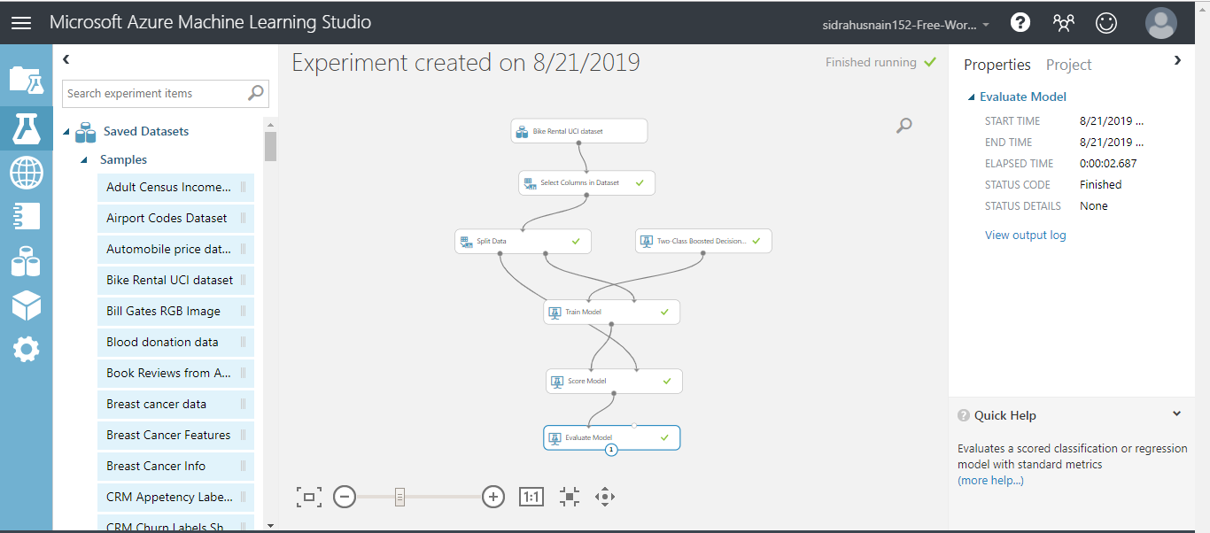

**Evaluate Model Results:**

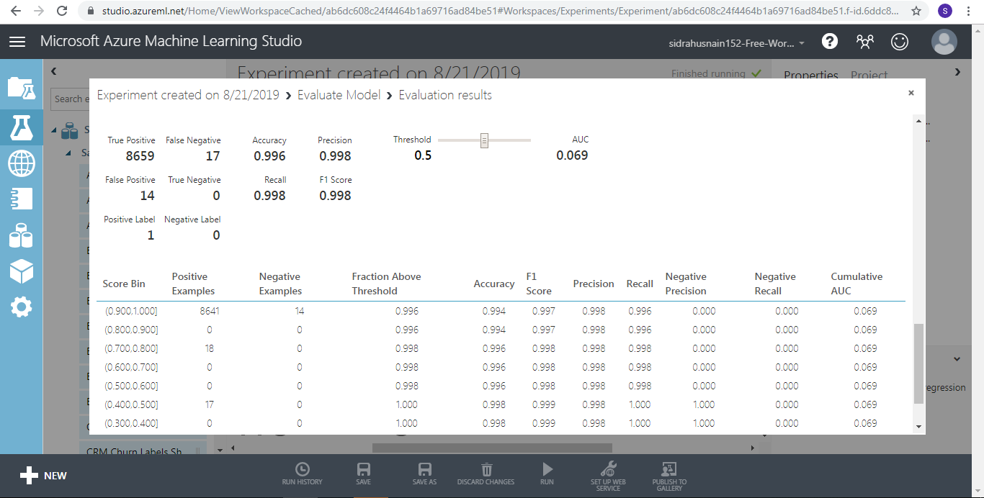

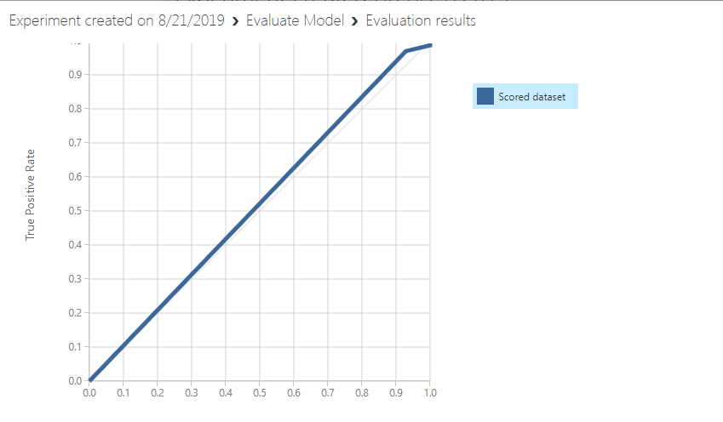

**Score Model Result:**

